**Individual Task: Programming Concept – Records (Structure)**

1. Go to <http://www.multiwingspan.co.uk/vb08.php?page=struct>
2. Read the contents on this page and review the example given

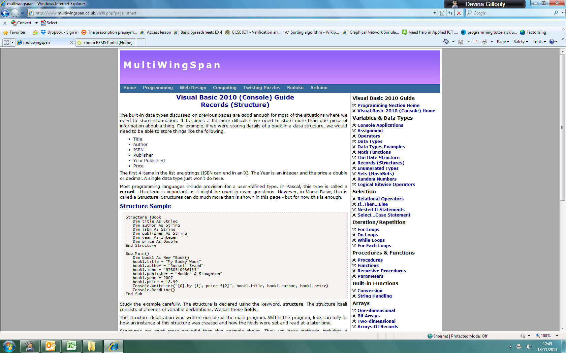

1. a) Plan a **structure** for CarDetails (type this into the Word document); to obtain details on Make, Model, Price, Registration, Colour, Doors.

b) Program the structure completed (a) in VB.NET.

|  |  |
| --- | --- |
| **Code** | **Console Output** |
| Module Module1  Structure CarDetail  Dim Make As String  Dim model As String  Dim price As Single  Dim registrationa As String  Dim colour As String  Dim door As Single  End Structure  Sub Main()  Dim car As New CarDetail()  car.Make = "Tesla"  car.model = "Model S"  car.price = 1255  car.registrationa = "Yes"  car.colour = "Black"  car.door = "2"  Console.WriteLine("{0}'s {1}, selling with {2}, registration {3}, colour {4} with {5} doors. ", car.Make, car.model, car.price, car.registrationa, car.colour, car.door)  Console.ReadLine()  End Sub  End Module |  |

1. Summarise this page to form notes on Structures, you should include the **definition**, **when Structures should be used**, as well as their **advantages** and **disadvantages**.

Structure is a collection of relative data with different data type

Structure is used in storing information of an object with multiple data type

Advantage: grouping and easier to understand and can be used multiple times, make the code cleaner

Store multiple data type into one structure

Disadvantage: structure type and variable name must be define before

Fixed data type, cannot changed

1. Review the 2014 Card Predict code (view the text file on Firefly) and answer the following questions:
2. Name a structure used in this code.

TCard

TRecentScore

1. Name a method (Functions/Subroutine) where the structure in (a) is used; provide a line number of where the structure is visible.

PlayGame

Main

LoadDeck

Shuffledeck

Displaycard

Getcard

isnextcardhigher

resetrecentscsore

displayrecentscores

updaterecentscores

playgame

***Additional Resource:*** [***http://www.dotnetperls.com/struc***](http://www.dotnetperls.com/struc) ***or*** [***https://www.dotnetperls.com/structure-vbnet***](https://www.dotnetperls.com/structure-vbnet)